 CHEMICAL ENGINEERING TRANSACTIONS  VOL. xxx, 2025 | A publication of  
The Italian Association
of Chemical Engineering
Online at www.cetjournal.it

Guest Editors: David Bogle, Flavio Manenti, Piero Salatino
Copyright © 2025, AIDIC Servizi S.r.l.
ISBN 979-12-81206-21-2; ISSN 2283-9216

Diesel-Biodiesel Blends Production, applied in the BD 5.0 Internal Combustion Engine to Evaluate the Future of Brazil´s Biodiesel Energy Matrix.
José D. Pinilla ^{a,d*}, Manuel A. Mayorga ^{b,d}, Henrique H. Junqueira ^{c}, Alexandre S. Dos Santos ª , Rogerio A. Melo ª, Marcela C. Nery ª.
ª Universidade Federal dos Vales de Jequitinhonha e Mucuri, Programa de Pós-graduação em Biocombustíveis, Diamantina MG, Brazil.
^{b} Universidad Libre, Avenida 70 # 53-40, Bogotá D.C, Colombia.
^{c} Usina de biodiesel Petrobrás, Avenida das indústrias 531 Distrito industrial, Montes Claros MG, Brazil MG, Brasil.
^{d} Universidad ECCI, Grupo de Investigación GIATME, Bogotá D.C, Colombia.
pinilla.david@ufvjm.edu.br

In South America, Brazil is the largest producer of biofuels in the world. This country has the fifth position with a significant opportunity to produce more biofuels, with potential in the biodiesel sector. Currently, in the country's transportation sector, the proportion of distribution of biodiesel blends with petrol diesel is 14%- B14, and the following year, it will be 15%- B15 until it reaches 20% or B20 in 2030. All this is to accomplish the United Nations' sustainable development goals in their numerals: 7 about clean energy, 9 about industry, innovation, and infrastructure, 11 about sustainable cities, 12 about responsible consumption and production, and the last 13 about climate action. The principal objective of this study is to evaluate the BD 5.0 diesel engine's behavior with different blends, obtain different parameters, and generate simulation in emissions results using the software DIESEL RK, all this to have a better technological alternative prediction route to apply in future blends of biodiesels. The results show significant correlations between the heat value in the biodiesel blends and the engine fuel consumption. In the developed simulations, lean fuel mixtures lambda λ of 1,5 are applied in the internal combustion engine, decreasing the temperature in the engine combustion chamber at high biodiesel blends, increasing the CO₂ levels, and diminishing the NO_{x} emissions, whereas at low biodiesel blends cold alternatives of combustion can diminish the temperature in the combustion engines chambers.
  - Introduction
In the world, Brazil is the 2nd country in biodiesel production, with approximately 8 million of m³ in 2024 (ANP., 2024); the country has a significant opportunity to expand its oilseeds crop matrix by a wide variety of sources apart from the traditional soybean (Glycine max), animal fats, used cooking oil, cotton seeds (Gossypium herbaceum), canola oil (Brassica campestris), and corn oil ( Zea mays), by other interesting non-edible oils resources like macauba (Acrocomia aculeata), dende (Elaeis guineensis), inajá (Attalea maripa), tucumã (Astrocaryum aculeatum G.), pinhão manso (Jatropha curcas), and mamona (Ricinus communis), (Hayder A., Alalwan., 2019). The diversification of raw materials diminishes dependence on only one oleaginous resource crop, which can be unstable due to climatic changes and the probable proliferation of dangerous plagues. A higher percentage of biodiesel blends utilized in internal combustion engines can develop better lubricity by their chemical double bond components, such as methyl linoleate C₁₉H₃₂O₂ and methyl oleate C₁₉H₃₆O₂, with more equilibrium in CO₂ emissions produced than can be reabsorbed by the plants to close their natural cycle, resulting in a more clean mobility.
  - Methodology
With the physiochemical characterization of biodiesel B100, provided by the PETROBRAS biodiesel plant in Montes Claros MG, Brazil to accomplish the ABNT requirements as shown in Table1 and figure 1; were elaborated different blends, starting from the commercial biodiesel- diesel B14, growing the quantity of biodiesel to obtain samples of 600 ml of B20, B25, B30, B40, B50, B70, B80, and B100, these blends was characterized in chromatographic gas analyzer-MS Shimadzu, Model GCMS-QP2010, which belongs to the multipurpose laboratory of University UFU in Itaiuticaba, MG, Brazil and evaluated in the UFVJM, campus II Diamantina MG in their density (specific mass), kinematic viscosity made by viscometer Brookfield Digital DV-III+ Ultra, not homologated by the normativity NBR 10441 and a heat value made by a calorimeter bomb IKA C5010 5012, all these characterization results were included in the simulation software Diesel RK where were introduced parameters like fuel characterization, engine configuration, fuel injection system, combustion chamber, gas exchange, and turbocharging system to be part to obtain approximate results to compare with the realized engine tests.
Table 1: Properties biodiesel B100.
Characteristics | Method | Specification | Result | Units
Aspect | NBR 16048 | LII | LII | Not applicable
Density (specific mass) at 20°C | NBR 14065 | 850 a 900 | 878,5 | kg m⁻³
Kinematic viscosity at 40°C | NBR 10441 | 3,0 a 5,0 | 4,272 | mm²/s
Water content | ASTM D6304 | 200,0 max. | 164 | mg/kg
Total contamination | EN 12662 | 24 max. | 23,9 | mg/kg
Flash Point | NBR 14598 | 100,0 min | 119 | °C
Ester content | EN 14103 | 96,5 min | 97,7 | % mass
Total sulfur | ASTM D5453 | 10 max. | 3,1 | mg/kg
Sodium Potassium content – Na+K | NBR 15553 | 2,5 max. | <1,0 | mg/kg
Calcium+ Magnesium content Ca+Mg | NBR 15553 | 2,5 max. | <1,0 | mg/kg
Phosphorus content | NBR 15553 | 4,0 max. | <1,0 | mg/kg
Clogging point | NBR 14747 | 19 max. | 4 | °C
Total acidity index | ASTM D664 | 0,50 max. | 0,34 | mg KOH/g
Methanol | NBR 15343 | 0,20 max. | 0,09 | % mass
Oxidation stability at 110°C | EN14112 | 13,0 min. | 19,1 | h
Diglyceride content | ASTM D6584 | 0,20 max. | 0,089 | % mass
Free glycerin | ASTM D6584 | 0,02 max. | 0,017 | mass
Total glycerin | ASTM D6584 | 0,23 max. | 0,162 | % mass
Monoglyceride content | ASTM D6584 | 0,60 max. | 0,493 | % mass
Triglyceride content | ASTM D6584 | 0,20 max. | 0,038 | % mass

Figure 1 shows the chromatographic analysis results in the fuel blends with R>0,94. The percentage of biodiesel shown in the abscissa axis significantly increases the components of C18:2 Methyl linoleate and C18:1 methyl oleate, where their double bonds form a dense adsorption film of molecules on the metal surface of the moving parts in the ICE. In minor proportions, components C16:0 and C18:0 represent the methyl palmitate and methyl stearate that increase with more biodiesel added to the blend (Wang., 2021).
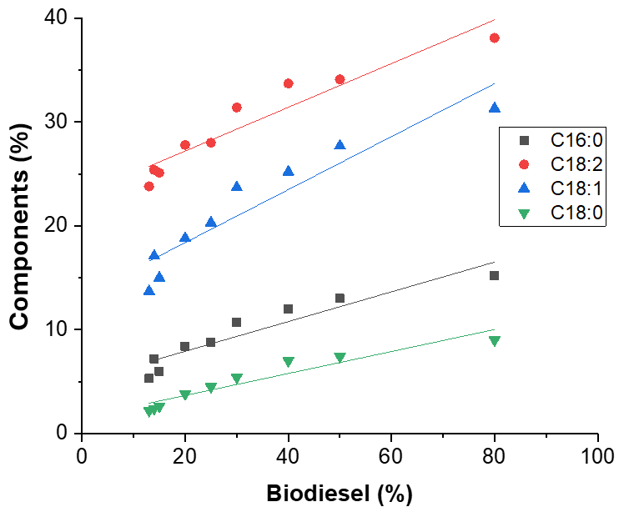
Figure 1. Percentual relations between biodiesel blends and fatty acid methyl esters FAME.
The diesel ICE model BD-5.0 utilized for the tests is a 4-stroke single-cylinder engine with an air-refrigerated block, overhead valve distribution OHV, a direct injection system of ± 21° CAD BTDC before the top dead center of the piston, and a fuel bomb pressure of 19,6 MPa. The engine specifications are shown in Table 2.
Table 2: Specifications ICE BD 5.0.
Single cylinder Diesel engine BD 5.0 G2 |  | Units
Displaced volume | 211 | cm³
Stroke | 55 | mm
Bore x Stroke | 70 | mm
Injection system | Direct | -
Compression ratio | 20:1 | -
Number of Valves | 1 for admission and 1 for exhaust | Unit
Refrigeration system | Air | -
Maximum Power | 5,0 HP at 3600 rev min⁻¹ | -
Continuous power | 4,2 HP at 3600 rev min⁻¹ | -

The dynamometric bench brake system consists of a 7.4 kW electrical engine connected to a load cell of 0,03% F.S. regulated by a potentiometer with variable charge levels from 0 to 100%. The ICE control acceleration is manual. A National Instruments electronic control module ECM NI USB-6009 makes the data acquisition; the configuration of the experimental engine connected to a dynamometric bench is shown in Figure 2.
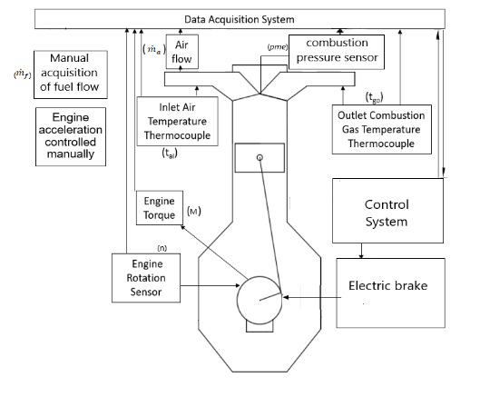

Figure 2: Engine test setup. Adapted from (Claudio Marcio Santana, 2024).
In the Mathematic applications, the Eq(1) of effective medium pressure, $emp$, is calculated, where $N_{e}$ is the effective power, $V_{T}$ is the volume of displacement of the engine, $n$ are the revolutions of the engine and $i$ is the number of cycles per revolution (González., 2011), this to compare the results between the pressure sensor GEFRAN K30 with precision < ± 0,25% FSO (H); < ± 0,5 % FSO (M) and the calculated values, where the encountered absolute errors and relatives are 0,08 kg cm⁻² and 2,0%.

$$emp=\frac{N_{e}}{V_{T}n i}$$ | (1)

The mass flow is calculated in a volumetric way Eq(2), where V is the volume in liters on the test calibration tube, and ρ is the fuel density (specific mass) in g cm-3, and t is the time that it takes for the test tube to be empty in hours depending the level of charge, where the applied specific consumption equation is the Eq(3):
$${\dot{m}}_{f}=\frac{Vρ_{c} }{t}$$ | (2)
$$c_{e}=\frac{\frac{Vρ_{c}}{t}}{N_{e}}=\frac{{\dot{m}}_{f}}{N_{e}}$$ | (3)
Table 3 shows: the Heat Value, $H_{c}$; Cetane number; Density (specific mass) $ρ_{c}$; and Viscosity. These properties were obtained in every diesel-biodiesel blend to be applied in the equations. The calculation of cetane number is obtained from Baharak, Sajjadi (2016).
Table 3: Physiochemical characteristics in biodiesel blends obtaining calorific power, density by NBR 14095, and the kinematic viscosity by NBR 10441 regulations.
Biodiesel  blend | Heat value  (kJ/kg) | Cetane number | Density at 20 °C  (kg m⁻³) | Viscosity at 40 °C  (cP)
B14 | 45,977 | 43 | 852 | 3,72
B20 | 45,515 | 44 | 854 | 3,84
B25 | 45,355 | 44 | 855 | 3,84
B30 | 45,085 | 44 | 856 | 3,72
B40 | 44,947 | 47 | 858 | 4,32
B50 | 43,706 | 47 | 861 | 4,32
B70 | 43,144 | 49 | 864 | 4,44
B80 | 42,153 | 50 | 870 | 4,32
B100 | 42,025 | 50 | 875 | 4,32
2.1 Experimental
All the blends were characterized, and every diesel–biodiesel sample was tested on the dynamometer bench at Ambiental conditions of temperatures between 23- 28 °C and barometric pressure of 0.89 bar, data are obtained every second regarding maximum torque generated at 2500 (± 50) rev min-1 and power at 3600 (± 50) rev min-1, specified by the ICE technical sheet BD 5.0. The potentiometer charges were manually increased to generate more brake power in the ICE.
2.2 Numerical simulation approach
In the software Diesel RK, 2010, based on the thermodynamics first law are introduced the measured engine configuration, ambient conditions of 27 °C and atmospheric pressure of 0,89 bar and 1,01 bar, fuel characterization, geometrical properties in the cylinder head, heat transfer, and frictional coefficients, design of the combustion chamber coefficient, effective area of piston rings, the relative duration of the injection, ignition time and pressure, diesel injector design, air-fuel equivalence, length of admission and exhaust manifold, dimensions of admission and exhaust valves, to obtain engine performances and emissions characteristics in the proposed fuel blends B14, B20, B30, B40, B50, B70, B80, and B100 in constant revolutions and compression ratio (Rajak,U., 2018), with lambda coefficient of 1.5, its given by the sum of available oxygen on the oxygen demanded (Guzella., 2009), as shown in the Eq(4):

$$λ=\frac{ΣO_{available}}{ΣO_{demanded}}$$ | (4)
  - Results and Discussion
The experiments carried out were developed to obtain the maximum experimental results in every proposed diesel-biodiesel blend in terms of maximum power and torque, with the values of emp, time, and fuel consumption at angular velocities of 3500 rev min-1 and 2500 rev min-1, which are shown in Table 4.
Table 4. Test results of maximum power, torque, consumption, and emp with different fuel mixtures of biodiesel-diesel.
 |  | Power, kW
Blend |  | B14 | B20 | B25 | B30 | B40 | B50 | B70 | B80 | B100
Angular velocity  rev min-1 | 2500 | 4,6 | 3,9 | 4,5 | 4,1 | 4,1 | 3,9 | 3,8 | 4,6 | 2,7
 |  | 4,2 | 3,4 | 3,4 | 3,4 | 3,8 | 3,9 | 4,0 | 3,4 | 4,2
 | 3500 | 4,3 | 4,7 | 4,5 | 4,8 | 4,5 | 4,9 | 5,0 | 4,8 | 4,6
 |  | 4,3 | 4,2 | 4,4 | 4,2 | 4,5 | 4,9 | 5,0 | 4,6 | 4,6
 |  | Torque, Nm
Blend |  | B14 | B20 | B25 | B30 | B40 | B50 | B70 | B80 | B100
Angular velocity  rev min⁻¹ | 2500 | 17,2 | 15,4 | 17,4 | 15,7 | 15,9 | 15,3 | 15,5 | 17,1 | 10,7
 |  | 17,1 | 13,4 | 13,0 | 13,3 | 14,4 | 15,0 | 15,6 | 13,4 | 13,8
 | 3500 | 12,1 | 12,8 | 12,6 | 13,4 | 12,9 | 13,5 | 13,9 | 13,4 | 12,7
 |  | 11,9 | 11,8 | 12,5 | 9,7 | 12,4 | 13,5 | 13,9 | 12,6 | 12,7
 |  | Consumption, g/kWh
Angular velocity  rev min⁻¹ | 2500 | 154,3 | 177,5 | 166,3 | 168,3 | 179,2 | 182,5 | 185,4 | 320,9 | 447,6
 |  | 155,0 | 190,5 | 172,0 | 196,5 | 198,9 | 189,5 | 188,1 | 379,2 | 418.6
 | 3500 | 200,6 | 197,7 | 242,1 | 219,2 | 220,4 | 232,0 | 363,2 | 423,5 | 508,4
 |  | 228,7 | 176,2 | 243,2 | 182,9 | 211,0 | 239,3 | 359,5 | 444,8 | 507,1
 |  | emp kg_{f} cm⁻²
Angular velocity  rev min⁻¹ | 2500 | 10,2 | 9,1 | 10,3 | 9,3 | 9,4 | 9,0 | 9,1 | 8,1 | 7,2
 |  | 10,1 | 7,9 | 7,7 | 7,9 | 8,5 | 8,9 | 9,3 | 7,9 | 8,5
 | 3500 | 7,2 | 7,6 | 7,5 | 7,9 | 7,3 | 8,0 | 8,2 | 7,9 | 7,6
 |  | 7,1 | 7,0 | 7,4 | 5,7 | 7,3 | 8,1 | 8,4 | 7,5 | 7,6

From the data in Table 4, an ANOVA analysis of power performance is elaborated in Table 5; the developed power diminishes in minor quantities in the angular velocity with 1 degree of freedom, neglecting their variation being statistically insignificant (Al-Iwayzy., 2017). The rev min-1 hypotheses are rejected because they statistically affect the dependent variable, a strong effect indicated by the F value and low P-value. The hypothesis is not rejected in the blends with 9 degrees of freedom in the tests is affected by increasing the quantity of biodiesel, because it does not statistically affect the mixture on the dependent variable indicated by the p-value more significant than 0,05. In the interaction interpretation, the hypotheses are not rejected without a significant effect if the combination factors do not affect the dependent variable. Differences in physical and chemical properties in high percentages of biodiesel in the lower heating value mean that the engine requires more fuel to reach high power and torque how, as shown in fuel consumption results in Table 4 (Wahlen., 2013).

Table 5: ANOVA of engine power performance, angular velocity, and the fuel blend.
Source | Degrees of freedom | SC | CM | F | F Critical | p-value | Reject hypothesis | Significant effect | % of Contribution
Rev min⁻¹ | 1 | 4,43 | 4,43 | 21,67 | 4,49 | 0,00026 | Yes | Yes | 45,98
Blend | 9 | 0,82 | 0,09 | 0,44 | 2,53 | 0,888 | No | No | 8,55
Interaction | 9 | 1,11 | 0,123 | 0,60 | 2,53 | 0,776 | No | No | 11,52
Error | 16 | 3,27 | 0,204
Total | 35 | 9,63 |  |  |  |  |  | R²=0.66 | *R²=0,45

Table 6 represents the ANOVA in the torque performance with angular velocities on 1 degree of freedom, representing a significant value P-value of 0,00029 with effect in the rev min⁻¹ on the dependent variable, rejecting the null hypothesis. The F- value of 21,23 is much greater than the F critical, with 4,49 being strong evidence against the null hypothesis. The blend does not have a significant effect with a value of 0,549, which is less than the F critical value of 2,53, where not is rejected the null hypothesis The R² indicates the 69% dependent variable variance, where after the adjustment, the number of predictors of 40% of the variance is explained. The only significant analysis value in the ANOVA is rev min⁻¹, contributing 40,10% of the variance. No significant differences were encountered in the calculated effective medium pressure (emp) compared to the experimental. Meanwhile, the increases in the biodiesel blend tend to produce minor emp because the minor heat value at high biodiesel blends is shown in Table 3 and Table 4 emp results with B70, B80, and B100 blends.

Table 6: ANOVA of engine torque performance, angular velocity, and the fuel blend.
Source | Degrees of freedom | SC | CM | F | F Critical | p-value | Reject hypothesis | Significant effect | % of Contribution
Rev min⁻¹ | 1 | 46,74 | 46,74 | 21,23 | 4,49 | 0,00029 | Yes | Yes | 40,10
Blend | 9 | 17,76 | 1,97 | 0,89 | 2,53 | 0,549 | No | No | 15,24
Interaction | 9 | 16,84 | 1,87 | 0,85 | 2,53 | 0,583 | No | No | 14,45
Error | 18 | 35,21 | 2,20
Total | 35 | 116,56 |  |  |  |  |  | R²=0,69 | *R²=0,40
The simulation results with the software Diesel RK in Figures 3a and 3b, were realized with comparative atmospheric pressures of 0,906 bar in Diamantina, Brazil at 1384 meters above the sea level and normal pressures of 1,01 bar, which is the atmospheric pressure at sea level. In the Figure 3A are compared the specific fuel consumption (C_{e}) and the specific emissions of CO₂, both measured in g kWh⁻¹, where the C_{e} and specific emissions of CO₂ were similar in different atmospheric pressures in almost all the blends. After the B80 blend at atmospheric pressure of 0,906 bar, the C_{e} increases from 346 g kWh⁻¹ to 837 g kWh⁻¹ in B100, similar growths were encountered for the specific emissions of CO₂ that changed In B80 from 1195 g kWh⁻¹ to 2539 g kWh⁻¹ in B100, meanwhile in the figure 3B after the B80 blend at atmospheric pressure of 0,906 bar, the specific emissions of NO_{x} decreased from 39,63 g kWh⁻¹ to 25,80 g kWh⁻¹, and the specific emissions of NO_{x} with the atmospheric pressure of 1,01 bar decreases from 38,98 g kWh⁻¹ in B80 to 33.41 g kWh⁻¹ in B100. This can be attributed to the low temperature in the combustion chamber due to the more consumed fuel to maintain the power and the same 3500 rev min⁻¹, at which the simulation is established. In Figure 3B at B40 blend, the NO_{x} generation blend tends to decrease to 19 g/kWh without affecting the C_{e} or CO₂ production because, at this point, the temperature of air admitted by the engine was modified, at 0 °C. In the exhaust of particulate matter PM after the B80 blend, this increases significantly in the atmospheric pressure of 0,906 bar, from 1,698 g kWh⁻¹ to 6,261 g kWh⁻¹, and in atmospheric pressure of 1,01 bar, the PM results grew from 1,642 g kWh⁻¹ in the B80 blend to 2,170 g kWh⁻¹.
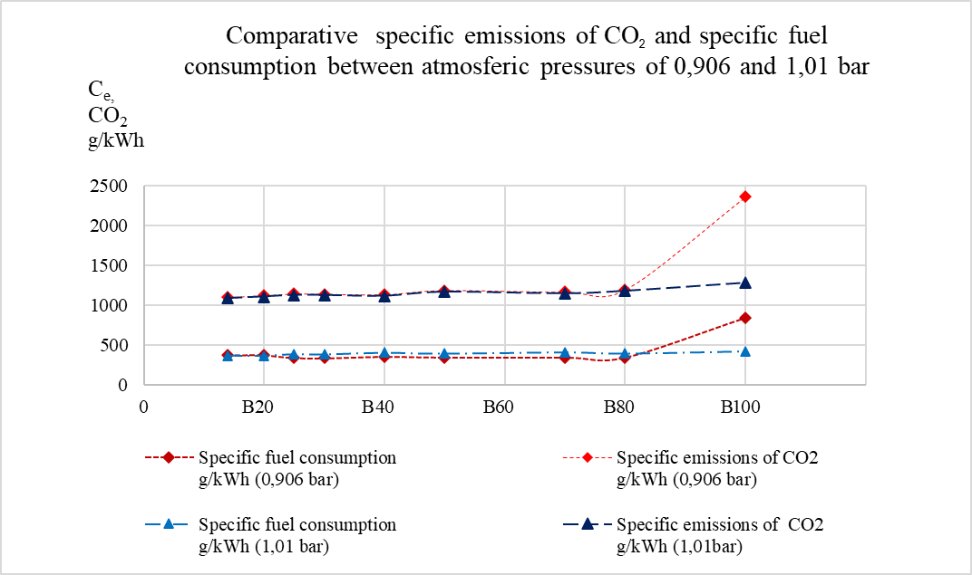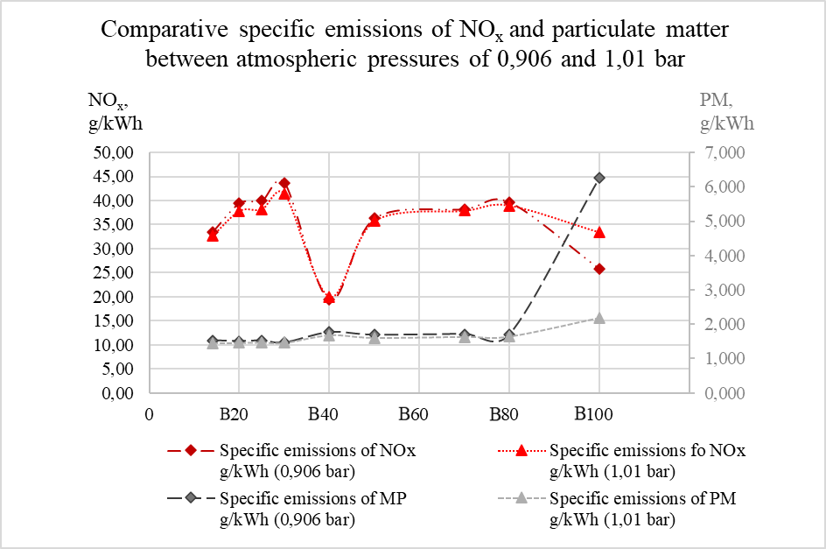
Figure 3: Simulation results in software Diesel RK for different biodiesel blends. 3a: Specific fuel consumption C_{e} and specific emissions of CO2 ,3b: Specific NOx emissions, and specific emissions of particulate matter.
Conclusions
The results of the experimental design analysis show that, with a 5% confidence level, there is statistical evidence that only the angular frequency (or velocity) factor has a significant effect on both engine power and torque. In the case of power, the model explains 66% of the results, while in the case of torque, the model explains 69%. With a 95% confidence level, the statistical evidence indicates that neither angular velocity nor fuel blend has a significant effect on specific consumption and mean effective pressure.
Due to its large quantities of arable land in Mato Grosso, Minas Gerais, Bahia, São Paulo, Goiás, and Rio Grande do Sul, Brazil can develop oilseed cultivation alternatives from non-edible sources to increase the amount of biodiesel blending in diesel, thus meeting the United Nations Sustainable Development Goals agreed for 2030. The experiments were conducted in the UFVJM city of Diamantina, Minas Gerais, at 1384 meters above sea level, where the low amount of oxygen available increased the consumption of biodiesel blends, which was much more critical after the B80 blend, producing more uncontrolled emissions of CO, CO₂, and particulate matter. B100 biodiesel has high lubricant properties with low heat value compared to the heat value of the B14 blend, where other alternatives have been proposed to improve the calorific properties of fuel oils through the hydrogenation process, with the necessity to control the NOx emissions through the alternative of low temperatures of air admitted that can solve the formation of these harmful gases. In the use of internal combustion engines, it is impossible not to generate CO₂ emissions; the emission of these gases must be controlled from natural sources of production, such as the use of biofuels or alternative fonts like efuels to reduce the global warming potential and carbon footprint.

Nomenclature

ABNT – Brazilian Association of Technical Standards
CAD – Crank Angle Degrees
CO – Carbon Monoxide
CO₂ – Carbon Dioxide
emp – Effective Medium Pressure
FAME – Fatty Acid Methyl Esters
FS – Full Scale Mass Flow
FSO – Full Scale Output
ICE – Internal Combustion Engine
m³ – Cubic Meters
NO_{x} – Nitrogen Oxides

N_{e} – Effective Power
V – Volume, L
V_{T} – Volume of Displacement of the Engine
$n$ – Revolutions of the Engine
$i$ – Number of Cycles per Revolution
${\dot{m}}_{f}$ – Mass Flow, g h-1
c_{e} – Specific Consumption
ρ_{c} – Density (Specific Mass), g cm-3
$t$– time in s or h
$λ$ – Lambda sum of available oxygen on the oxygen demanded

Acknowledgments
Universidade Federal dos Vales do Jequitinhonha e Mucuri (UFVJM), Instituto de Ciência y Tecnologia (ICT), e órgãos de fomento CNPq, FAPEMIG e CAPES. Planta PETROBRAS Biocombustível Montes Claros MG Br.
References
Al-Iwayzy, Y. T. (2017). Diesel engine performance and exhaust gas emissions using microalgae Chlorella protothecoides biodiesel. Renewable energy an international journal, págs. 690-701 https://doi.org/10.1016/j.renene.2016.09.035.
Baharak Sajjadi, A. A. (2016). A comprehensive review on properties of edible and non-edible vegetable oil-based biodiesel: Composition, specifications and prediction models. Renewable and Sustainable Energy Reviews, 62-92 https://doi.org/10.1016/j.rser.2016.05.035.
Claudio Marcio Santana, L. L. (01 de 04 de 2024). Experimental analysis of the thermal energy balance of an Otto cycle engine operated with ethanol and gasoline. SIMEA, pags. 1-8.
González, F. P. (2011). Motores de combustión interna alternativos. Valencia: Reverté.
Guzella, L. O. (2009). Introduction to modeling and control of internal combustion engine systems. En G. Lino, Introduction to modeling and control of internal combustion engine systems (pags. DOI 10.1007/978-3-642-10775-7). Milan: Springer Science & Business Media.
Hayder A. Alalwan, A. H. (2019). Promising evolution of biofuel generations. Subject review, Focus, 127-139.
P. McCarthy, M. R. (2011). Analysis and comparison of performance and emissions of an internal combustion engine fueled with petroleum diesel and different bio-diesels. FUEL, 2147-2157 https://doi.org/10.1016/j.fuel.2011.02.010.
R.E. Pauls. (2011). A Review of Chromatographic Characterization Techniques for Biodiesel and Biodiesel Blends. Journal of Chromatographic Science, 384-396.
RK, D. (2025 de 02 de 2010). Engine simulation tool DIESEL RK. Obtenido de https://diesel-rk.com/Eng/
UN. (11 de 12 de 2024). https://sdgs.un.org/goals. Obtenido de https://unstats.un.org/sdgs/files/report/2024/SG-SDG-Progress-Report-2024-advanced-unedited-version.pdf: https://sdgs.un.org/goals
Upendra Rajak, P. N. (2018). Numerical investigation of performance, combustion and emission characteristics of various biofuels. Energy Conversion and Management, 235-252 https://doi.org/10.1016/j.enconman.2017.11.017.
Wahlen, B. D. (17 de 01 de 2013). Biodiesel from microalgae, yeast, and Bacteria: Engine Performance and Exhaust Emissions. American Chemical Society, pag. 220-228.
Wang, W. (2021). Effects of unsaturated fatty acid methyl esters on the oxidation stability of biodiesel determined by a gas chromatography-mass spectrometry and information entropy methods. Renewable energy an internal journal, 880-886 https://doi.org/10.1016/j.renene.2021.04.132.

